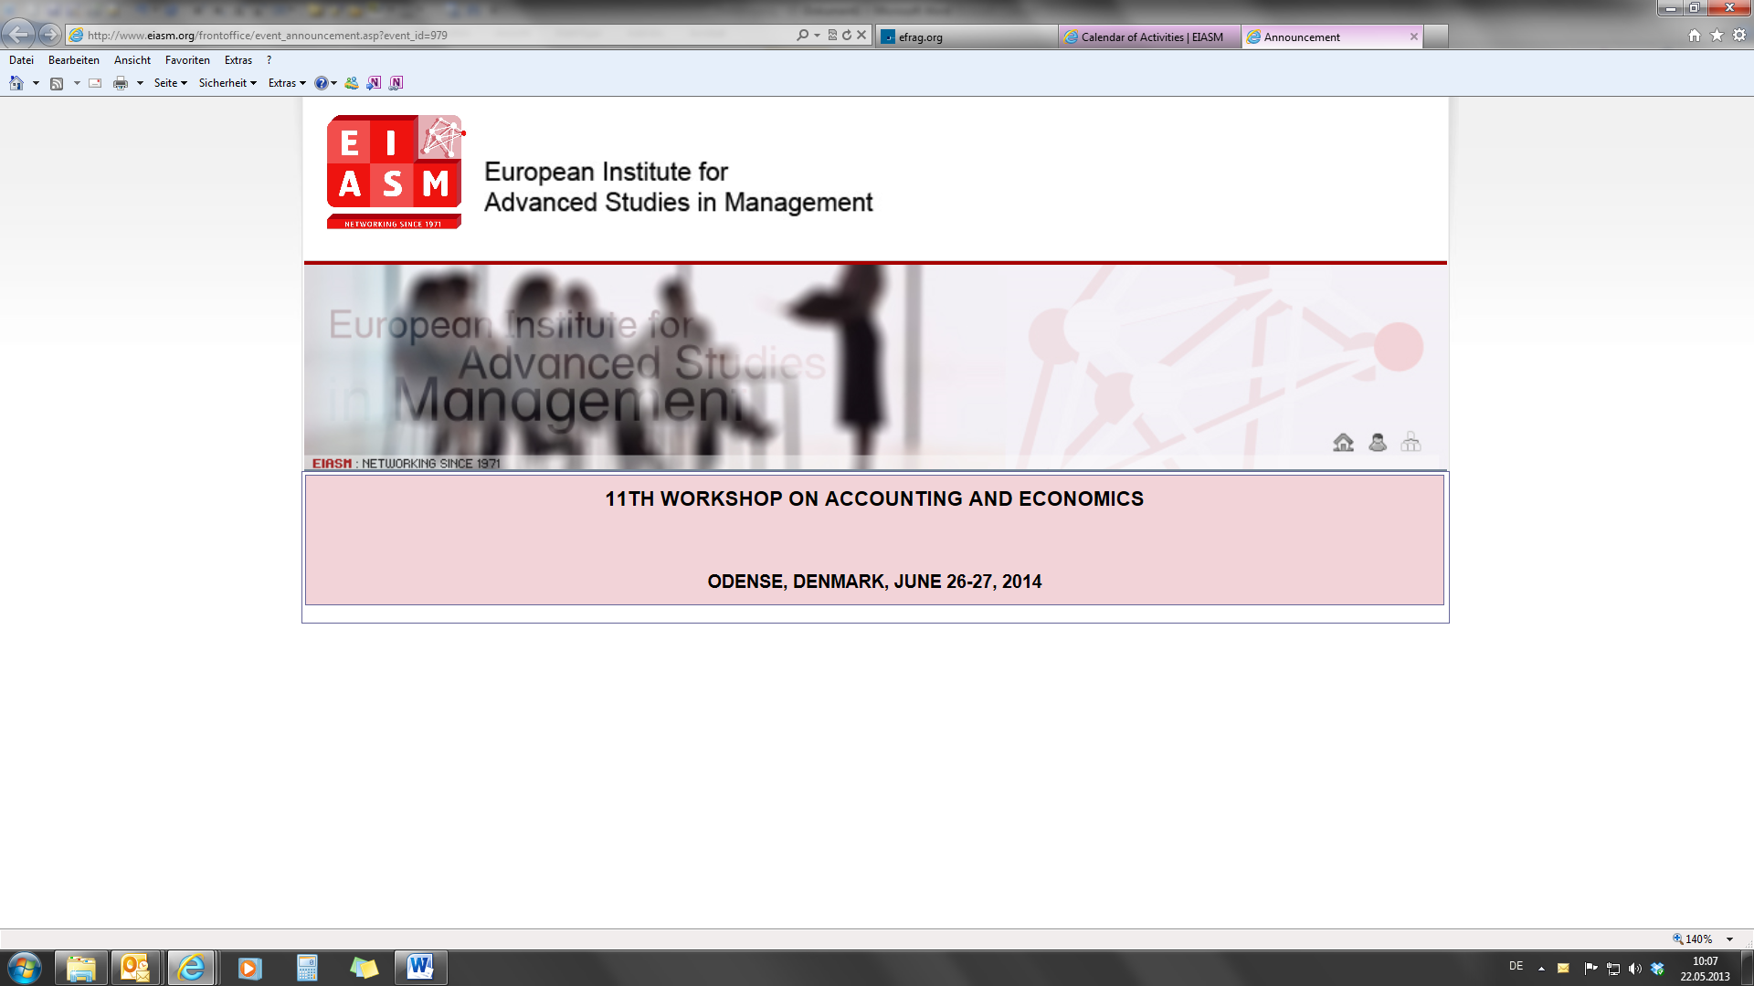

|  |
| --- |
| **13TH WORKSHOP ON ACCOUNTING AND ECONOMICS** |
| **PARIS, FRANCE, JUNE 21-22, 2018** |

**Accommodation**

Here are some hotels suggested :

PLEASE BE AWARE THAT ON   
June 21,   
France celebrates the “fête de la musique”.   
  
We strongly recommend that your book your hotel early.

**Residhome Courbevoie La Défense**

49 avenue de l'Arche

92400 - COURBEVOIE

Tel : +33 (0)1 55 70 36 00 / Fax : +33 (0)1 55 70 36 01

http://www.residhome.com/reservation/appartements-courbevoie-138.html

**Citadines Paris La Défense**

Les Saisons, 1-8 Boulevard de Neuilly,

92400 Courbevoie

Tel : +33 1 58 13 57 57

http://www.citadines.com/france/paris/citadines-la-defense-paris/index.html

**Pullman Paris La Défense**

11 Avenue de l'Arche, 92800 Courbevoie

Tel : +33 1 47 17 50 00

http://www.accorhotels.com/gb/hotel-3013-pullman-paris-la-defense/index.shtml

*10% de réduction sur le meilleur tarif disponible du jour /* 10% discount on *room rates of the day*

*Petit déjeuner inclus / Breakfast included*

In order to take advantage of the 10 % reduction, please refer to contract number SC261641677 with SKEMA Business School”.

**Apparthotel Séjours et Affaires Résidence Grande Arche**

11 Allée des Tilleuls, 92800 Courbevoie

Tel : +33 1 45 57 40 40

http://www.accorhotels.com/gb/hotel-3013-pullman-paris-la-defense/index.shtml

**Getting to the campus**

By plane: Paris has two international airports, Paris Orly and Charles de Gaulle. Both are connected by the local railway RER B. Take RER B in the direction of the center of Paris. Change at station “Chatelet – Les Halles” and take the RER A in Western direction (terminal stations Cergy Le Haut, Poissy, or Saint Germain en Laye). Get off at La Défense Grande Arche. From here the school and the hotels are within a short walking distance.



By public transport: Metro line 1, Stop at station "Grande Arche de la Défense" RER A, Stop at station "Grande Arche de la Défense" SNCF train, Stop at station "La Défense" from Saint Lazare Paris Station. Exit: A, E or CNIT / TAXI station – in the direction of the pedestrian bridge that spans the Circular Boulevard (access Carpeaux Place, next to the sculpture of Caesar's Thumb), then take the alley where there are statues with cut wings or arms (CNIT to be behind you).

By car: Circular Boulevard of La Defense by “Pont de Neuilly” (Neuilly Bridge). Exit “La Défense 6 - Direction La Garenne-Colombes”, after first traffic light turn right on “Boulevard de la Mission Marchand” then take 2nd left to get to the Avenue Leonard de Vinci. Or Exit “La Défense 12 – Faubourg de l’Arche” keep straight and right across the bridge over the railway. Keep going after the traffic light on Avenue Léonard De Vinci.

Parking:

8, avenue Léonard de Vinci